EE 101 Engineering Orientation 15.11.2021
2021 – 2022 Midterm Exam
Q1) by Oğuzhan Çiftdalöz
Consider a car of mass $m$ with horizontal force $u$ (due to the engine) and aerodynamic drag force $βv^{2}$.
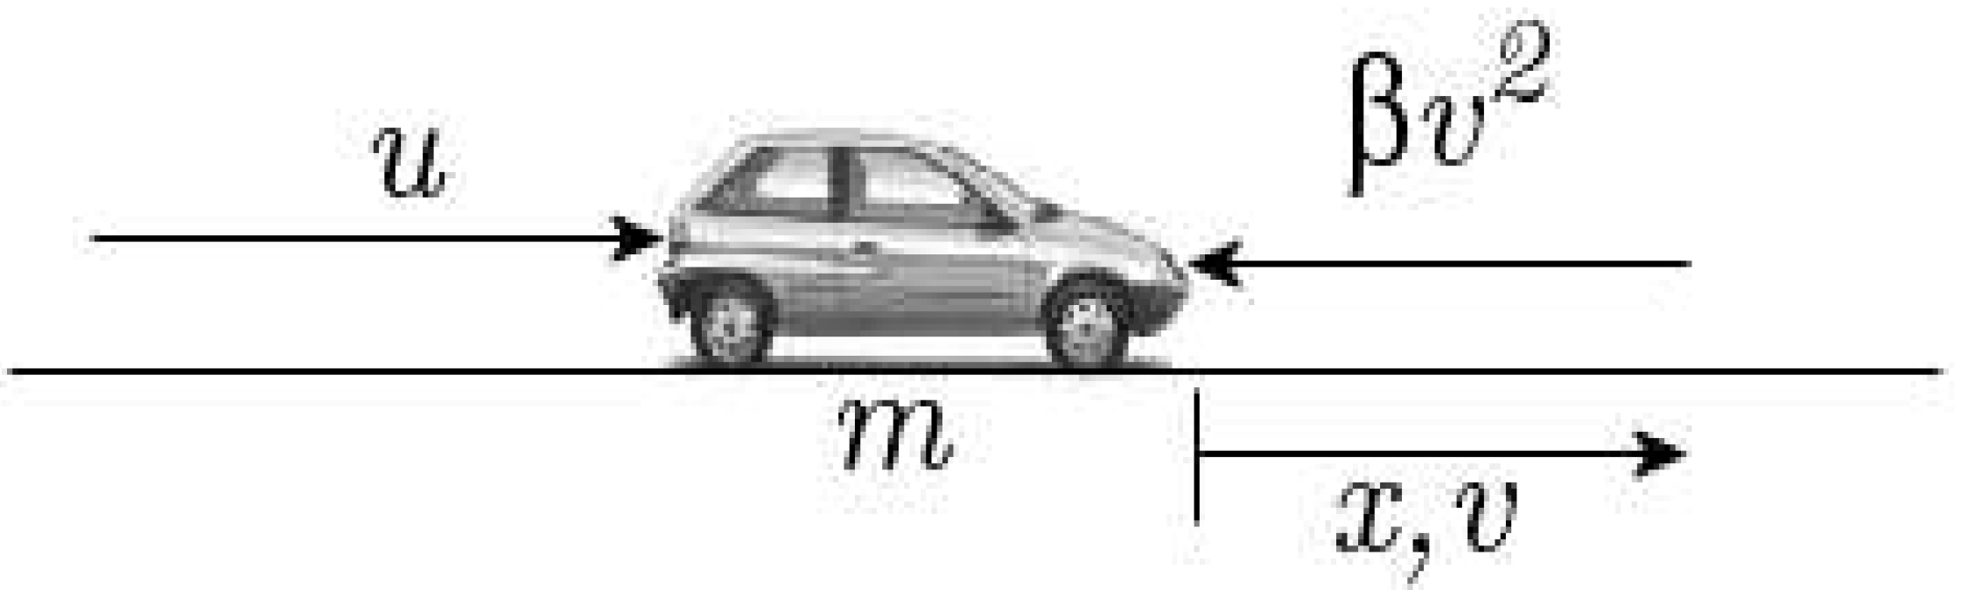
- Write down the nonlinear diﬀerential equation which relates the velocity $v$ to the input force $u$.
- If the car is travelling at a given constant velocity $v_{o}$, compute the required force applied by the engine.
Q2) by Yahya Kemal Baykal
Write 5 different types of signals that can be transmitted in a telecommunication system.
Q3 ) by Göker Şener
- Which of the followings is TRUE for insulators ?
a-) They have many free electrons.
b-) Metals are insulators.
c-) Electrons can be separated and move easily.
d-) Electrons are tightly bound to the atomic core.
- For the same conductivity constant (σ), which of the followings has the most resistance ?
a-) A wire with large cross sectional area.
b-) A wire with long length.
c-) A wire with small length.
d-) None of the above.
- Which of the following electrical devices consumes the most power under the same constant voltage ?
a-) 10 Ω b-) 50 Ω c-) 100 Ω d-) 1000 Ω
- Which of the followings is NOT a reason for using “AC” in electrical energy usage ?
a-) Easy to generate.
b-) Possible to use transformers.
c-) Possible to use ground.
d-) Installation costs are lower.
- Which of the followings is NOT true for a transformer ?
a-) It can decrease the amplitude of the voltage/current.
b-) It has two windings (primary and secondary).
c-) It can increase the amplitude of the voltage/current.
d-) It can work with DC and AC.
Q4) by Barbaros Preveze
What is the name of the operation to pass signal through a System? and What is Sampling used for?

SOLUTIONS
Q1
a)
$$m\dot{v}=u-βv^{2}$$

b) Since$v=v_{o}=constant$, $\dot{v}=0.$ So,
$$0=-\frac{β}{m}v_{o}^{2}+\frac{1}{m}u \underset{→}{yields} u=βv_{o}^{2}$$
Q2) 1D, 2B, 3A, 4C, 5D
Q3)
Voice
Data
Image
Video
Text
Combination (Multimedia)
Q4)
The name of the operation to pass signal through a System is “Convolution” .
Signal is sampled to convert an analog signal into its digital form?

